[1]

|  |
| --- |
|  |
| |  |  | | --- | --- | | Value of Statistical Luggage | | | Group Members: | Aashna Khetani | |  | Ajya Sah | |  | Ayush Yajnik | |  | Rushabh Barbhaya | |  | Sharuk Tharun Senthil Kumar | |
| |  |  |  | | --- | --- | --- | |  |  |  | |

Table of Contents

Summary 2

Just how Big the Problem is? 3

Montreal Convention 3

Cost to airlines 4

Newark International Airport 4

1. Manual System Vs Machine System 4

2. Newark Airport Scenario 5

3. Sensitivity Analysis 5

4. Risk Management 8

5. Smaller airport 8

Implementation Cost 8

Sensitivity of Cost range to Liability Cost Amount 9

How Baggage Fee’s existence plays a role in Decision Making? 10

Recommendations 10

References 12

# Summary

The objective of the report is to discusses the problems of mishandled baggage [2] in the current aviation system, focusing on domestic US flight operations.

There were about 858 Million enplanements in the year 2017 and they checked-in about 660 Million bags in the same year of which about 2.3 Million bags were reported damaged/pilfered/delayed and about 105,000 bags were stolen. Similarly, for 2016 the number of enplanements is about 830 Million with about 638 Million checked-in bags of which 2.2 Million bags were reported damaged/pilfered/delayed and about 102,000 bags were stolen.

Airlines paid about $2.8 Billion for mishandled bags and about $330 Million for stolen bags in 2016. In 2017, they paid $2.9 Billion in mishandled bags and about $340 Million for stolen bags.

For Newark International Airport (EWR) with about 40 Million annual enplanements, if we were to implement the Human Checking System it would cost about $1.5 Million & $1.2 Million for Machine Checking System. To prevent the losses to airlines, the whole system needs to be funded by the airline industry. If this system were to be implemented in EWR it would save about $10 Million annually. The human system is highly sensitive to the TSA security personnel count. Similarly, the machine system is sensitive to the personnel count of TSA engineers. There will be 2 major issues if EWR would run this on trial basis. First, the implementation would require all the airlines to use the special tagging system. Second, the training costs. Smaller airports operate on a minimum to no profit basis. There the cost of implementing these systems without the financial aid of government would be next to impossible. Still a human system would cost less than the machine system by $20,000.

The cost of implementing either of these systems to the top 500 commercial airports would be about $1 Billion for human system and about $700 Million for machine system. If liability limit changes by ± 1σ the output will change by ≈ $600 Million. Airports are not responsible for any baggage related issues. The passengers pay the airlines for keeping their baggage safe and deliver it to them at the end of the journey. If there are any error which occur along the way, airlines usually pay the passengers in terms of cash or kind.

We recommend a hybrid system, which may cost more but the errors are way less. This will cost the passengers no more than $10 on their ticket price.

# Just how Big the Problem is?

Nationally and internationally there have been multiple reports of luggage being stolen from the airports. It causes discomfort to all the involved entities but mostly to the passengers and to the airlines.

Figure : Ratio of stolen bags to reports.

In United States, there are about 660 Million checked bags [3]. Although the number of mishandled reports has been going down year over year, it still costs millions of dollars to airline industry. The number of mishandled cases in 2017 is just shy of 3 bags per 1000 passengers. With the rise in number of passengers traveling through airplanes, the report of 0.3% loss means there are about 2.3 Million lost bags annually. From the mishandled bags, 5%-7% are stolen or reported lost. [4] [5]

Table : Mishandled and Stolen Bags

|  |  |  |
| --- | --- | --- |
|  | 2016 | 2017 |
| Enplanements | ≈ 829 Million | ≈ 858 Million |
| Checked-in Bags | ≈ 638 Million | ≈ 660 Million |
| Mishandled Bags | ≈ 2.2 Million | ≈ 2.3 Million |
| Stolen Bags | ≈ 102,000 | ≈ 105,000 |

We are only considering domestic cases in this report. We are not considering any international flights to or from United States. We are considering the 17 major air carriers as mention in the BTS reports [2]. The whole system is about to use technology, like, RFID or NFC. We are also assuming that the aircraft doesn’t stay at the airport for more than 8 hours or overnight. We are also not accounting for peak hours and idle hours. The maximum weight of the aircrafts is 100,000 lbs.

# Montreal Convention

Montreal Convention is a multilateral treaty signed by the members of ICAO (International Civil Aviation Organization) in 1999 to amend some important provisions made during the previous Warsaw Convention.

According to Article 22 [6] of the Montreal Convention, It’s the airline’s liability in the case of death or injury to passengers, as well as in cases of delay, damage or loss of baggage and cargo. It unifies all the different international treaty regimes covering airline liability that had developed haphazardly since 1929. MC99 is designed to be a single, universal treaty to govern airline liability around the world. For Lost Baggage, it has been unified by the members of the ICAO that the airlines can pay a passenger up to a maximum limit of 1,131 SDR’s. SDR is the abbreviated form of Special Drawing Rights by the International Monetary Fund (IMF). The value of 1 SDR, as of writing this report is $1.37.[1]

# Cost to airlines

Airlines earned close to $30 Billion from checked bags in 2017 and close to $300 Billion from basic ticket sale [7]. Model employed does not include in entirety, all the costs that account for revenues and expenses for the airlines [8] [9] [10] [11] [12]. After accounting for the payment to the airports, airline industry earned about $235 Billion (not accounting for Market Shares, Buying/Selling/Renting aircrafts, Public ramp and apron charges, Security charges, Police tours requests, etc.). The maximum liability to a ticketed passenger for a damaged/pilfered/lost bag is $3,300. A sample of the calculation is shown below.

Table : Mishandled and Stolen Bags Cost to airlines

|  |  |  |
| --- | --- | --- |
|  | 2016 | 2017 |
| Mishandled Bags Cost | ≈ $2.8 Billion ± $50 Million | ≈ $2.9 Billion ± $50 Million |
| Stolen Bags Cost | ≈ $330 Million ± $10 Million | ≈ $340 Million ± $10 Million |

Airlines pay nearly $3 Billion in the case of mishandled bags. And about $350 Million are paid to passengers whose bags are lost.

# Newark International Airport

## Manual System Vs Machine System

Ranges:

|  |  |  |
| --- | --- | --- |
| Inputs to model | Manual | Machine |
| No of Security | 10 – 18 | NA |
| Individual Security Pay | $28K – $41K | 0 |
| No. of Engineers | NA | 2 – 4 |
| Individual Engineer Pay | 0 | $54K – $72K |
| No. of Check posts | 3 – 5 | 3 – 5 |
| No. of equipment | 0 | 4 – 6 |
| Proportion of bags stolen | 5 – 7 % | 5 – 7 % |
| Liability per passenger | $3,300 | $3,300 |
| Implementation Costs for EWR | $1.5 Million | $1.2 Million |
| Net profit | ($44Million) Loss | $10 Million Gains |

We get these values by also considering the errors caused by humans as well as by machines. According to CREAM and HEART theory [13], error committed by a human usually is up to 20.7% and if 3 security personnel are working on a machine if considering the human error, then the total human error on a single machine comes up to be around 1% (considering the error from every security personnel). According to the IEEE report [14], error caused by a machine is 0.1% so with this error, the number of stolen bags is reduced.

## Newark Airport Scenario

After the Cost Benefit Analysis of the two Systems Recommended, Machine System is found to be the better choice over the Human System due to Risks associated with Employing Humans and Cost of Implementing. The Table below describes the effect that implementing the machine system would bring to the Newark Airport in terms of No. of Bags that can be prevented from being stolen as well as the Liability cost associated with it.

Table : System Implementation Comparison

|  |  |  |  |  |
| --- | --- | --- | --- | --- |
|  | Before Implementation | After Implementation | Difference | Percent of Change |
| No. of Bags | 4,934 | 493 | 4,441 | 90.01% |
| Liability Cost | $ 16,282,728.00 | $ 1,628,272.80 | $ 14,654,455.20 | 90.00% |

## Sensitivity Analysis

Formula for Costs:

*Costs = Personnel (Security and Engineers) Salary + Equipment Cost + Costs for lost bags as per liability costs and error rate for each system.*

*Assumed there are no maintenance costs and operational costs. All handling will be done by engineers in charge who are paid salaries.

**Manual System**

**Agenda:** A person is assigned for the task of checking (matching tags) manually at check posts established. As this is human system, equipment cost is 0 and there is no need for engineers, just security personnel. Human error is 20.7% as per CREAM report.

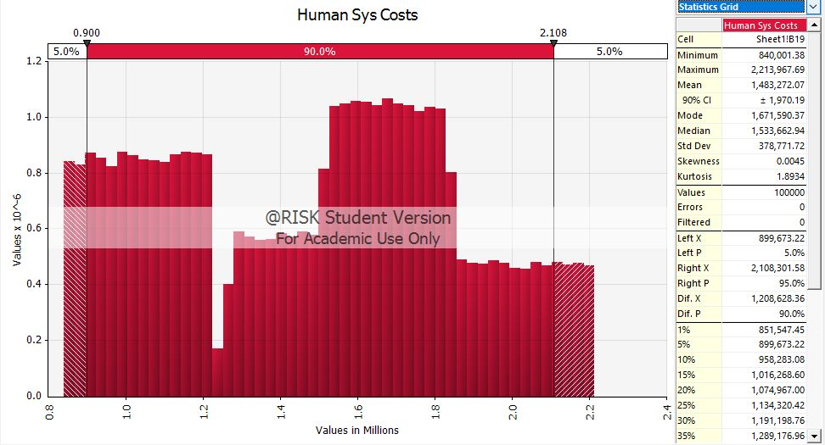

Figure : Distribution of Costs for Manual System

The distribution shows that range of costs for a human system is about $1.5 Million. 90% Confidence interval is about ± $2000 i.e. 90% of the time our output (costs) will fall within that range from mean.

The input variables and their sensitivity to output is illustrated by the following Spider Graph:

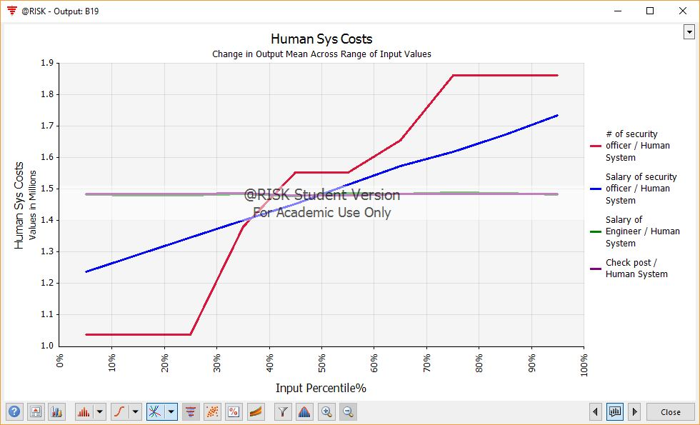

Figure : Sensitivity Report for Manual System

Clearly, the output costs are most sensitive to No. of security officers and their salaries.

**Limitations:** Time Consuming, Bottlenecks at peak times.

**Machine System**

**Agenda:** Machines are employed for scanning and matching RFID. Machine error rate is 0.1% as per IEEE report (significantly low!).

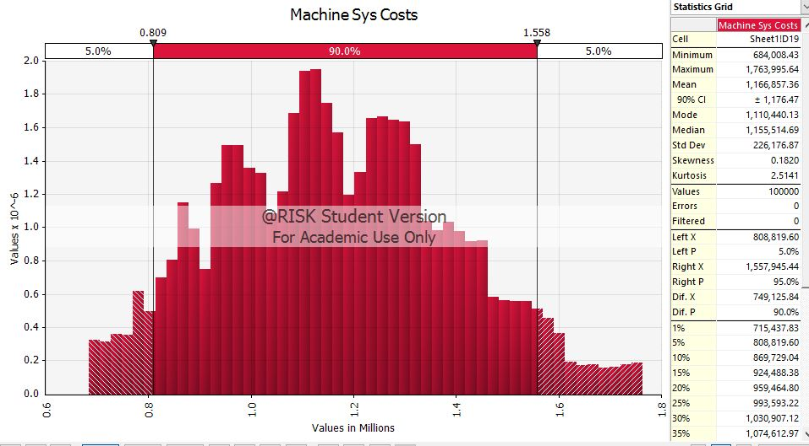

Figure : Output Distribution for Machine System

The distribution shows that range of costs for a human system is about $ 1.2 Million. 90% Confidence interval is about ± $1200.

The input variables and their sensitivity to output is illustrated by the following Spider Graph:

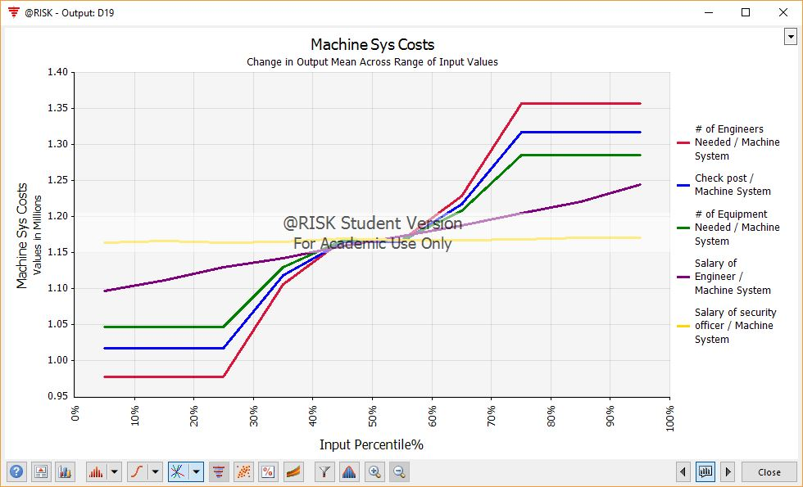

Figure : Sensitivity report for Machine System

It is apparent from the reports that our model output is most sensitive to no. of engineers needed, no. of check posts, and no. of equipment employed in decreasing order of effects.

The degree of these sensitivity is given by Regression Mapped Value Tornado graph:

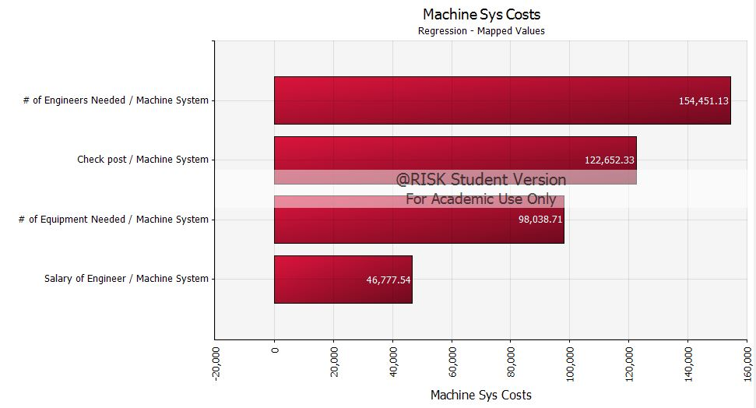

Figure : Regression Mapped Value Tornado Graph for Machine System

So, 1 standard deviation change in the input variable – No. of engineers with other inputs constant, the output of changes approx. by $150K. Similarly, for other input variables.

**Limitations:** New system so training personnel for that, new software/hardware glitches could happen.

## Risk Management

Table : Risk Matrix

|  |  |  |  |  |  |  |
| --- | --- | --- | --- | --- | --- | --- |
| Risk Matrix | | *Chances* | | | | |
| **Very Low** | **Low** | **Medium** | **High** | **Very High** |
| **Occurrence** | **Very Often** |  |  |  |  |  |
| **Often** |  |  |  |  | **3** |
| **Mid** |  |  | **4** | **2** | **1, 6** |
| **Rare** |  |  |  |  |  |
| **Very Rare** |  |  |  |  | **5** |

**Risks:**

1. Electrical Failure:

Includes Shutdown of Power, Improper power supply, Short Circuit, Improper Power connection or improper grounding of the electrical system

1. Machine Failure:

Includes Freezing of Machine, Scanner issues, Wire Disconnecting, Corrosion, Thermal Stressing, Wear and Tear

1. Damage to the RFID Tag:

Includes Wear and Tear damage to the tag, Broken RFID chip in the Tag, RFID get Erased, Improper Sealing of Bag Tag, Damage during Transit.

1. RFID Error:

Includes Tag Collision, Incompatibility, Manual Overwriting of RFID data, Hacking of RFID Data.

1. Terrorist Attack

Chance of happening of the event is quite low but when considering it as an extreme case, its severity is quite high.

1. Human Error:

Includes Idleness, Lapse of Memory, Skill Based Error, Slips of Actions

## Smaller airport

It will be cheaper to implement the human baggage verification on smaller airports. By smaller airports we mean about 5,000 enplanements. The human model costs about $150,000 ± $10,000; whereas the machine model will cost around $250,000 ± $20,000 to implement.

The number of errors caused by humans will be more than the machine ones, but it is easier to manage those mistakes at a smaller airport, because of lower foot traffic. The chances of misreading a bag with normal CREAM method, in theory, comes to less than 3 bags annually.

# Implementation Cost

For the implementation of this project government regulation will be needed on the domestic scale. The cost of implementing the human system for top 500 commercial airports is around $1 Billion ± $150 Million. For the machine system implementation cost is $380 Million ± $20 Million.

# Sensitivity of Cost range to Liability Cost Amount

Shown by Regression Mapped Value Tornado Graphs. These costs are with respect to the costs incurred when the bags are lost after the system implementation. So, the model output cost here is just the cost incurred due to lost bags and the attempt is to show how these costs will change as per liability cap changes.

**Manual System:** Graph shows that one standard deviation change in the liability amount will change the output costs by approx. $6 Million and similarly for other input.

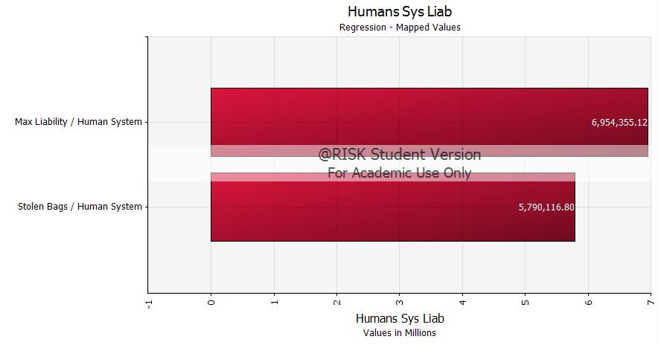

Figure : Human System Costs Sensitivity to Liability Cap

**Machine System:** Graph shows that one standard deviation change in the liability amount will change the output costs by approx. $600 K.

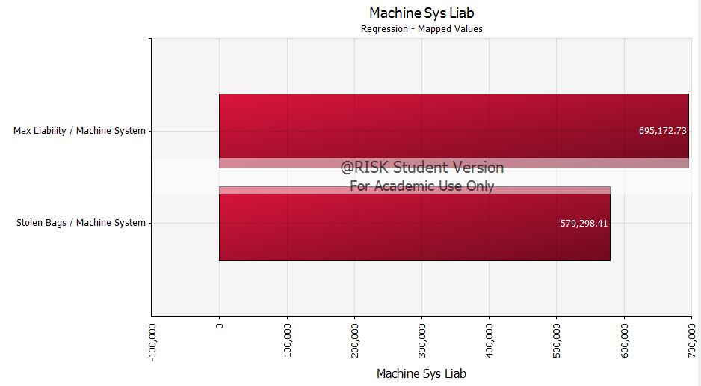

Figure : Machine System Costs Sensitivity to Liability Cap

**Observations**: Here, the sensitivity of output is more for manual system probably because human error rate is greater than machine error rate which results in more lost bags for manual and ultimately more costs. All in all, we can say that human system ought to be rejected in any case as per the analyses discussed. However, costs incurred for both systems and overall profit consequently indicates or makes pace for the proposal of a new system that will employ machines with humans, which is explained further in recommendations.

# How Baggage Fee’s existence plays a role in Decision Making?

Almost all airlines charge some fees for checking the bags [15] [16] [17] [18] [19] [20] [21] [22] [23] [24]. 76% of the passenger’s check-in their bags and pay the additional fee. The liability paid to victim passengers collectively is higher than the fee they collect from all the passengers who check-in their bags. Hence, some part of every ticket sold by the airline accounts for the liability of the stolen bags.

Airports aren’t affected by the issue of lost/stolen bags as they do not have responsibility with it. Airlines are responsible for paying the liability costs to the passengers.

When a baggage of passenger is lost, the airlines pay them liability in the form of either Cash / Check / Voucher or credits to your account which may or may not be able to satisfy the interest of the passengers.

# Recommendations

Benefit cost analysis of the discussed systems i.e., Humans or Machine was conducted, and these seem to have their own limitations.

Irrespective of the scenario, airlines are responsible for lost baggage because airline staff is solely responsible for handling the customer’s baggage, right from the origin to destination, thus incurring $3,300 per bag. Looking at the cumulative liability costs before and after implementing the systems (Table 3), it is apparent that it is beneficial for the airlines is to consider implementing a system because this will only help them cut liability payments for stolen bags. As for other mishandled bags which include delayed and pilfered baggage, more research is required as to what system could help with those problems.

The Airports should take the responsibility of maintaining the system so that they can reduce the error rate to a great extent. The passenger’s responsibility, or rather a no other choice scenario, is to accept the changes in the fare after implementation of a security system and they ought to adapt themselves to the new system with an understanding that it only helps save their bag from being stolen. The Passengers gets affected when the airlines increase the fare to implement this system.

Based on the values from above, the airlines can implement the system without increasing the fare. But a system can’t be implemented without increasing the fare. Hence the Airlines can increase the fare in two ways, one is to increase the Airfare by $5 to $10 to over all customers and other way is to increase the check in bags charges.

Analyses show that machine is better than manual with higher profits. To get around the limitations and benefits of both these systems we present a hybrid system.

**Alternate Solution: Hybrid of Manual and Machine**

Humans equipped with RFID scanners will be present at Check posts to ensure security.

This system is found to be little costlier than the previous ones, but the error rate is as low as almost 0.07% [25]. This could help to airlines to exploit the pros of both systems. Results would be beneficial for the airlines to save money they spend on liability although this system implementation at the start requires a good investment.

Range of costs for Hybrid System: (Analysis based on EWR scenario)

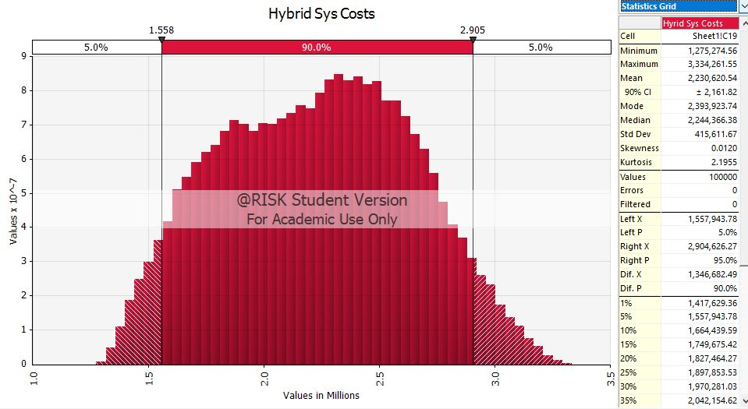

Figure : Costs distribution for Hybrid System

For an airport like EWR, the range of costs after implementing a hybrid system is about $2 Million with 90% CI being ± $ 2K. Initial investment seems high, the error rate being low the probability of stolen bag occurrences is significantly reduced, thereby helping our prime concern.

# References

|  |  |
| --- | --- |
| [1] | jcomp, Artist, *Business Photo Created.* [Art]. www.freepik.com, 2019. |
| [2] | Bureau of Transportation Statistics , "Number 30 – Technical Directive: Mishandled Baggage, effective Jan 1, 2019," U. S. Department of Transportation , 1 January 2019. [Online]. Available: https://www.bts.dot.gov/topics/airlines-and-airports/number-30-–-technical-directive-mishandled-baggage-effective-jan-1-2019. [Accessed May 2019]. |
| [3] | IPSOS Public Affair, "Status of Air Travel in USA," 13 April 2016. [Online]. Available: http://airlines.org/wp-content/uploads/2016/04/2016Survey.pdf. [Accessed 6 May 2019]. |
| [4] | SITA, "Baggage Report 2017," SITA, [Online]. Available: https://www.sita.aero/resources/type/surveys-reports/baggage-report-2017. [Accessed 3 May 2019]. |
| [5] | SITA, "Baggage Report 2018," SITA, [Online]. Available: https://www.sita.aero/resources/type/surveys-reports/baggage-report-2018. [Accessed 3 May 2019]. |
| [6] | The International Air Transportation Association, "Essential Documents on International Air Carrier Liability," The International Air Transportation Association, [Online]. Available: https://www.iata.org/policy/Documents/MC99_en.pdf. [Accessed 15 May 2019]. |
| [7] | Bureau Of Transportation, " Average Domestic Airline Itinerary Fares," United States Department of Transportation, 2018. [Online]. Available: https://www.transtats.bts.gov/AverageFare/. [Accessed 8 May 2019]. |
| [8] | 100ll, "100ll.com," [Online]. Available: http://100ll.com/. [Accessed May 2019]. |
| [9] | Bureau Of Transportation Statistics, "Search Airline Employment Data by Month," U. S. Department of Transportation, [Online]. Available: https://www.transtats.bts.gov/Employment/. [Accessed 16 May 2019]. |
| [10] | T. P. A. o. N. &. N. Aviation Department, " Schedule of Charges For Air Terminals," Jan 2018. [Online]. Available: https://www.panynj.gov/airports/pdf/scheduleofcharges-jfk.pdf. [Accessed May 2019]. |
| [11] | Bureau of Transportation Statistics, "Airline Fuel Cost and Consumption (U.S. Carriers - Scheduled)," U.S. Department of Transportation, [Online]. Available: https://www.transtats.bts.gov/fuel.asp. [Accessed 16 May 2019]. |
| [12] | United States Department of Transportation, "Federal Aviation Administration," Federal Aviation Administration, 7 Nov. 2018. [Online]. Available: https://www.faa.gov/airports/planning_capacity/passenger_allcargo_stats/passenger/. [Accessed May 2019]. |
| [13] | A. B. Pouya and E. Habibi, "The comparative study of evaluating human error assessment and reduction technique and cognitive reliability and error analysis method techniques in the control room of the cement industry," in *International Journal of Environmental Health Engineering*, 2015. |
| [14] | G. Fritz, V. Beroulle, M. Nguyen, O. Aktouf and I. Parissis, "Read-Error-Rate evaluation for RFID system on-line testing," IEEE, La Grande Motte, 2010. |
| [15] | Delta Airlines, "Baggage and Travel Fees," Delta Airlines, 2018. [Online]. Available: https://www.delta.com/content/www/en_US/traveling-with-us/baggage/before-your-trip/checked.html/#BaggageFees. [Accessed 4 May 2019]. |
| [16] | Southwest Airlines, "Checked Baggage," Southwest Airlines, 2019. [Online]. Available: https://www.southwest.com/html/customer-service/baggage/checked-bags-pol.html. [Accessed 5 May 2019]. |
| [17] | American Airlines, "Checked bag policy," American Airlines, 2018. [Online]. Available: https://www.aa.com/i18n/travel-info/baggage/checked-baggage-policy.jsp. [Accessed 2019 May 2019]. |
| [18] | Frontier Airlines, "Bag Option," Frontier Airlines, [Online]. Available: https://www.flyfrontier.com/travel/travel-info/bag-options/. [Accessed 4 May 2019]. |
| [19] | Alaska Airlines, "Checked Baggage, Rules and Fees," Alaska Airlines, 2018. [Online]. Available: https://www.alaskaair.com/content/travel-info/baggage/checked-bags. [Accessed 4 May 2019]. |
| [20] | Allegiant Airlines, "Optional Services & Fees," Allegiant Airlines, [Online]. Available: https://www.allegiantair.com/popup/optional-services-fees#services-fees-table-button. [Accessed 4 May 2019]. |
| [21] | Spirit Airlines, "Bag," Spirit Airlines, [Online]. Available: https://www.spirit.com/OptionalServices#Fare-Price. [Accessed 4 May 2019]. |
| [22] | United Airlines, "Checked baggage," United Airlines, [Online]. Available: https://www.united.com/web/en-US/content/travel/baggage/checked-baggage.aspx. [Accessed 4 May 2019]. |
| [23] | Hawaiian Airlines, "Baggage Fees," Hawaiian Airlines, [Online]. Available: https://www.hawaiianairlines.com/bagfees. [Accessed 4 May 2019]. |
| [24] | JetBlue Airlines, "Bag Info," JetBlue Airlines, [Online]. Available: https://www.jetblue.com/at-the-airport/baggage-information. [Accessed 4 May 2019]. |
| [25] | Barcodes, "Portable/Handheld RFID Reader," Barcodes, [Online]. Available: https://www.barcodesinc.com/cats/rfid-readers/portable.htm. [Accessed May 2019]. |
| [26] | Federal Aviation Administration, "Air Traffic By The Nurmbers," 2018. [Online]. Available: https://www.faa.gov/air_traffic/by_the_numbers/media/Air_Traffic_by_the_Numbers_2018.pdf. [Accessed May 2019]. |
| [27] | Kimberly Amadeo, "Federal Reserve Discount Rate," The Balance, 22 April 2019. [Online]. Available: https://www.thebalance.com/federal-reserve-discount-rate-3305922. [Accessed May 2019]. |
| [28] | Bureau of Transportation Statistics, "2017 Annual and December U.S. Airline Traffic Data," U. S. Department of Transportation, [Online]. Available: https://www.bts.dot.gov/newsroom/2017-annual-and-december-us-airline-traffic-data. [Accessed May 2019]. |
| [29] | Federal Aviation Administration , "Budget Estimates 2010," 2010. [Online]. Available: https://www.faa.gov/about/office_org/headquarters_offices/aba/budgets_brief/media/fy%202010%20president's%20budget%20submission.pdf. [Accessed 5 May 2019]. |
| [30] | ATLAS RFID Store, "Handheld RFID Readers," ATLAS RFID Store, [Online]. Available: https://www.atlasrfidstore.com/handheld-rfid-readers/. [Accessed May 2019]. |
| [31] | TSA, "Airport Security & TSA Travel Tips," TSA, [Online]. Available: https://tsatraveltips.us/tsa-jobs/. [Accessed May 2019]. |
| [32] | N. S. Bardell and H. Yue, "A discussion about how efficiently the major US airlines are using their domestic fleets of Boeing 737-800 aircraft," in *Australasian Transport Research Forum (ATRF)*, Darwin, Australia, 2018. |
| [33] | LabCE.com, "Barcode Reading and Accuracy," LabCE.com, 2019. [Online]. Available: https://www.labce.com/spg650115_barcode_reading_and_accuracy.aspx. [Accessed May 2019]. |
| [34] | FederalLawEnforcement.org, "Salary Expectations for Airport Security Jobs," FederalLawEnforcement.org, 2019. [Online]. Available: https://www.federallawenforcement.org/tsa/. [Accessed May 2019]. |
| [35] | AirNav, "Newark Liberty International Airport," AirNav.com, [Online]. Available: https://www.airnav.com/airport/KEWR. [Accessed May 2019]. |
| [36] | GlobalAir, "Aiation Fuel," Global Aviation Navigator, Inc, [Online]. Available: https://www.globalair.com/airport/region.aspx. [Accessed 10 May 2019]. |
| [37] | wikipedia, "Fuel economy in aircraft," wikipedia, 2019. [Online]. Available: https://en.wikipedia.org/wiki/Fuel_economy_in_aircraft. [Accessed 11 May 2019]. |

1. Read more about the conversion → <https://www.imf.org/external/np/fin/data/rms_sdrv.aspx>